WE ARE LOOKING FOR SUMMER INTERNS!
The Congressional Leadership Fund (CLF) is the leading Super PAC supporting Republican candidates for the U.S. House. CLF plans to spend $100 million during the 2018 cycle, while maintaining more than 35 grassroots field offices across the country.
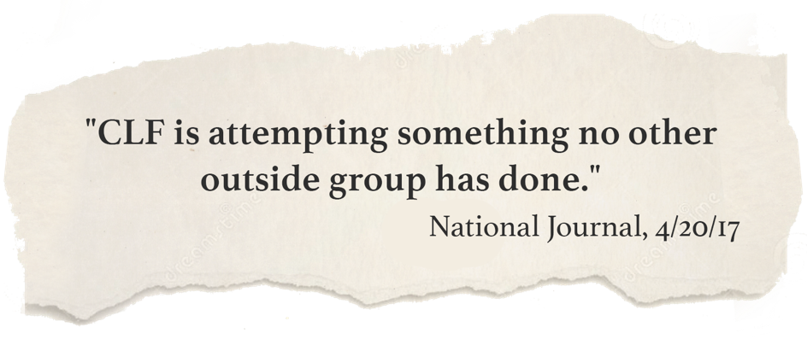
Join the Top Grassroots Effort in the Country
Fantastic opportunity for those interested in building a resume and learning more about campaigns and politics. Flexible hours and able to work with busy schedules. Interns may earn college credit with this internship. | INTERNS WILL BE EXPOSED TO:  - Campaign Strategy  - Voter Targeting and Contact Methods  - Grassroots Organizing and Networking  - Discussion of Current Political Issues  - National Media Coverage

“The team values each member of its crew and encourages them to work their hardest; and in turn rewards their initiative. The future of politics is looking bright with organizations like the CLF taking a new lead” - GA-06 Intern

CONTACT IF INTERESTED:
Nathan Kelley, nkelley@theclf.org

Paid for by the Congressional Leadership Fund www.CongressionalLeadershipFund.org and not authorized by any candidate or candidate’s committee

